ECA5403-ELECTROMAGNETIC FILEDS AND WAVES
C02-2
EXPERIMENT 7
Aim:
To determine and plot the capacitance of an isolated sphere and a concentric spherical capacitor for different radii and dielectric constants using MATLAB.
Test Case (i) – Capacitance of an Isolated Sphere
Determine the capacitance for a specified radius and relative permittivity.
MATLAB Program:
clc;
clear;
epsilon0 = 8.854e-12;
a = input('Enter radius of isolated sphere (m): ');
er = input('Enter relative permittivity: ');
epsilon = epsilon0*er;
C = 4*pi*epsilon*a;
disp('Capacitance of isolated sphere (F) =');
disp(C);
OUTPUT:
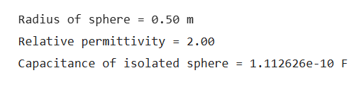
Test Case (ii) – Variation of Isolated-Sphere Capacitance with Radius
clc;
clear;
epsilon0 = 8.854e-12;
er = 1;
a = linspace(0.1,2,100);
C = 4*pi*epsilon0*er.*a;
plot(a,C,'LineWidth',2); grid on;
xlabel('Radius a (m)'); ylabel('Capacitance C (F)');
title('Capacitance of an Isolated Sphere vs Radius');
OUTPUT:
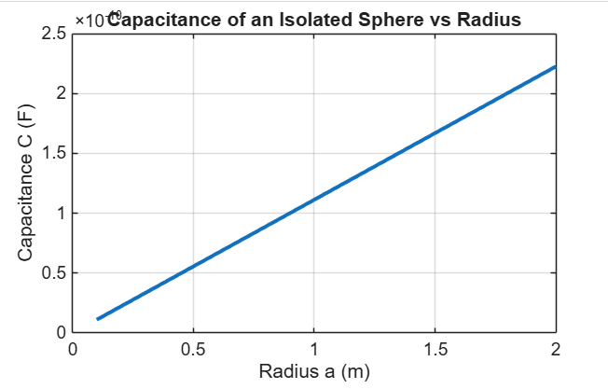
Test Case (iii) – Capacitance of a Concentric Spherical Capacitor
Determine the capacitance for specified inner radius a, outer radius b and relative permittivity εr.
clc;
clear;
epsilon0 = 8.854e-12;
a = input('Enter inner radius a (m): ');
b = input('Enter outer radius b (m): ');
er = input('Enter relative permittivity: ');
epsilon = epsilon0*er;
C = 4*pi*epsilon*a*b/(b-a);
disp('Capacitance of concentric spherical capacitor (F) =');
disp(C);
OUTPUT:
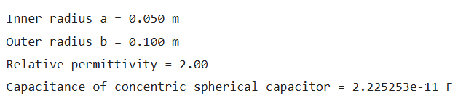

Test Case (iv) – Effect of Outer Radius and Relative Permittivity
clc;
clear;
epsilon0 = 8.854e-12;
a = 0.05;
er = 2.5;
b = linspace(0.06,0.20,100);
C1 = 4*pi*epsilon0*er.*a.*b./(b-a);
figure; plot(b,C1,'LineWidth',2);
grid on;
xlabel('Outer radius b (m)');
ylabel('Capacitance C (F)');
title('Concentric Sphere: Capacitance vs Outer Radius');
er = linspace(1,6,100);
b = 0.10;
C2 = 4*pi*epsilon0.*er.*a.*b./(b-a);
figure; plot(er,C2,'LineWidth',2);
grid on;
xlabel('Relative permittivity er');
ylabel('Capacitance C (F)');
title('Concentric Sphere: Capacitance vs Relative Permittivity');

OUTPUT:
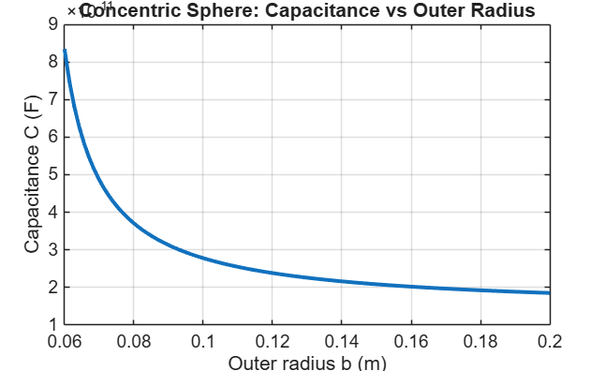
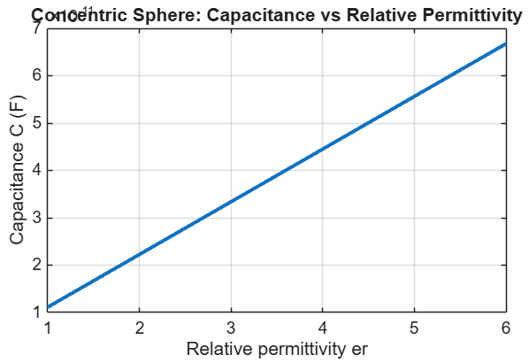

Objective | Assessment Criterion | Excellent – 4 | Good – 3 | Satisfactory – 2 | Needs Improvement – 1 | Weighting | Marks given | Marks obtained
Define spherical geometry and dielectric | Define spherical geometry and dielectric | Correctly identifies isolated-sphere radius or inner/outer radii and medium permittivity. | Geometry is correct with minor omission. | Some dimensions or material properties are unclear. | Uses invalid geometry or material inputs. | 25 | 2.5
Implement spherical capacitance equations | Implement spherical capacitance equations | Applies the appropriate isolated/concentric sphere formulas correctly. | Formulas are mostly correct with minor errors. | Partial calculations require guidance. | Uses incorrect equations. | 25 | 2.5
Analyze radius and permittivity effects | Analyze radius and permittivity effects | Compares cases and validates the expected capacitance trends against theory. | Analysis is mostly correct with minor omissions. | Comparisons or validation are incomplete. | No valid trend analysis is shown. | 30 | 3.0
Present results and conclusions | Present results and conclusions | Reports geometry, units, calculations and conclusions clearly. | Report is clear with minor gaps. | Report lacks some key information. | Results are unclear or missing. | 20 | 2.0
TOTAL |  |  |  |  |  | 100 | 10

